**Sort: Ascending Order**

**Input**:

/*Enter the data*/

data data;

input name$gender$age YearExperience$;

datalines;

Swathi f 23 1

Ram m 24 2

Ammu f 25 2

Anu f 26 3

Keerthana f 25 1

Abhi m 26 3

Manisha f 24 3

Ankitha f 23 0

Datha m 26 4

Aniketh m 28 5

Sanju f 27 4

Lohith m 25 1

Sharath m 26 2

Kavana f 22 0

Suhas m 25 1

;

run;

proc print data = data;

run;

**Output:**

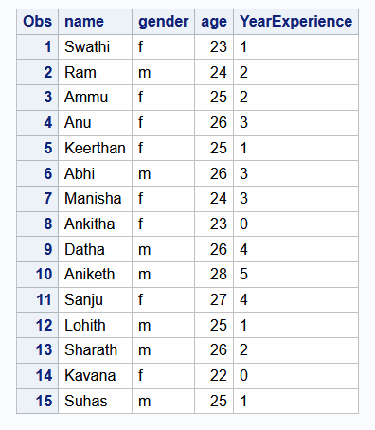

**Input**:

/* sort name*/

proc sort data = data;

by name;

run;

proc print data = data;

run;

**Output**:

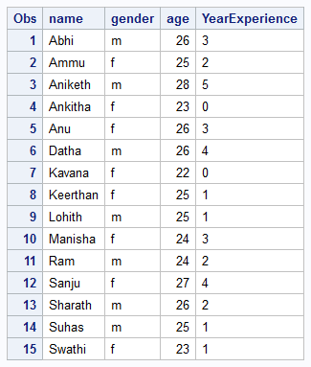

**Input**:

/*sort the data based on gender*/

proc sort data = data;

by gender;

run;

**Output:**

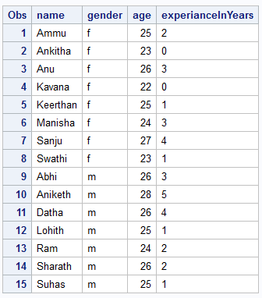

**Input:**

/*sort the data based on age*/

proc sort data = data;

by age;

run;

**Output:**

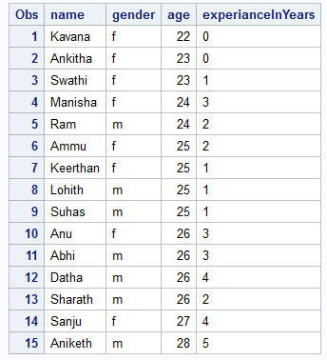

**Input:**

/*sort based on experience*/

proc sort data = data;

by experianceInYears;

run;

**Output:**

